CS6825 Keras Tutorial
By a CS6825 student, Song Mei
See github https://github.com/meis725/kerasExample

What is Keras?
Keras is a high-level neural networks API, written in Python and capable of running on top of TensorFlow, CNTK, or Theano. It was developed with a focus on enabling fast experimentation. Being able to go from idea to result with the least possible delay is key to doing good research (keras.io).
For more info: https://keras.io/

How to Install Keras?
Since keras is a front-end API running on top of the tensorflow, make sure install tensorflow first before keras.
Click here to install tensorflow
After you get your tensorflow running, here are the two options install keras:
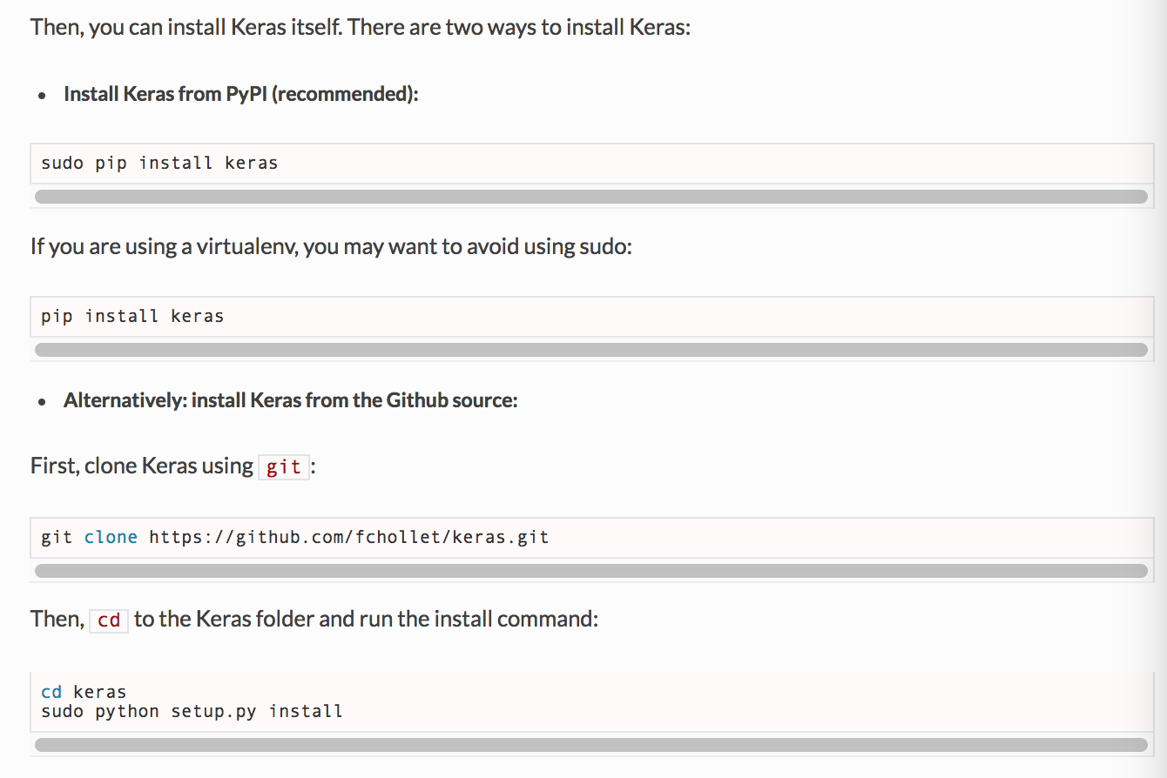
More info: https://keras.io/

Working Example: Github repository
This working example use to classify facial expression recognition. The size of the input image is 48 * 48. There are total 1122 training examples and 250 testing examples, I only selected a small portion of data to speed up the training. You may find the entire dataset here: Kaggle challenge.
Version info:
- Python 3.61.
- Keras 1.2.2.
- Tensorflow 1.40.
- Numpy 1.12.1.
- Pandas 0.19.2.
- Matplotlib 2.0.0.
- H5py 2.7.1.

Read comments in the example project for more info.

Frequently asked questions:
Q: import error "from keras.regularizers import l1, activity_l1 "?
A: Keras changed l1, activity_l1 function in keras version 2.0, check latest doc here: Keras. Or install Keras 1.2.2.
Q: What is the input/output node's name in my tensorflow model(.pb) file?
A: 1. run "kerasToTF" function in the example code. Or check this Keras_to_tensorflow
2. Maybe you can use Tensorboard.
Q: Why the classification accuracy so low in the example program?
A: Because I only included 1122 training samples to speed up the training process, the real dataset contains total 28709 examples.
Q: Where is the output model located?
A: The output model (.pb) file should appear under your project folder/tensorflow_model/constant_graph_weights.pb

Other recommended resources:
- A Guide to Running Tensorflow Models on Android
  - Project Github repository
- Good book for tensorflow

